ELEC408-Computer Vision

HW2-Hybrid Images

Report

7.11.2016

EKİN AYÜREK

ID:31459

Table of Contents

1. Introduction 3

# Introduction

In this assignment we are required to implement SIFT-like (Scale Invariant Feature Transform) algorithm in *Matlab*. I had a skeleton project code in the beginning and I should implement *get_interest_points.m*, *get_features.m*, *match_features.m* functions. In addition, we will prove that correlation matrix in colour gradients is an optimization problem for gradients. I also tried to make my algorithms scale-invariant for the bonus part of the homework. I will briefly explain my algorithm and after that I will show my results which are better than the result in the assignment website [1].

# get_interest_points.m

I use Harris corner detection from our textbook [2]. I converted the image double image for more robust calculations.

**image = im2double(image)**

After that I defined my Gaussian filter for smoothing the image. It was very dependent to image. I found the best sigma values empirically and I will show them in the results section. The filter size is recommended to be feature_width. However, I found that feature_width+1 is works better than feature_width+1. I assume that, odd number of filter size is better because it centres the pixel.

**sigma = 0.7;**

**gaussian_filter = fspecial('Gaussian', feature_width+1, sigma);**

If the image colored, I use collar gradients in order to calculate correlation matrix. If the image I user intensity gradients. I use Matlab’s *imgradientxy*function to calculate gradients and I use*imfilter* function filter images. If the images is colored, then I get the color gradients.

[g_ch1x, g_ch1y] =imgradientxy( imfilter( squeeze(image(:,:,1) ), gaussian_filter));

[g_ch2x, g_ch2y] = imgradientxy( imfilter( squeeze(image(:,:,2) ), gaussian_filter));

[g_ch3x, g_ch3y] = imgradientxy( imfilter( squeeze(image(:,:,3) ), gaussian_filter));

And our correlation matrix is:

$C=D^{T}D=\left[\begin{matrix}g_{ch1x} & g_{ch2x} & g_{ch3x} \\ g_{ch1y} & g_{ch2y} & g_{ch3y}\end{matrix}\right]\left[\begin{matrix}g_{ch1x} & g_{ch2y} \\ g_{ch2x} & g_{ch2y} \\ g_{ch3x} & g_{ch3y}\end{matrix}\right]$

$$=\left[\begin{matrix}{g_{ch1x}}^{2}+{g_{ch2x}}^{2}+{g_{ch3x}}^{2} & g_{ch1x}*g_{ch1y}+g_{ch2x}*g_{ch2y}+ g_{ch3x}*g_{ch3y} \\ g_{ch1x}*g_{ch1y}+g_{ch2x}*g_{ch2y}+ g_{ch3x}*g_{ch3y} & {g_{ch1y}}^{2}+{g_{ch2y}}^{2}+{g_{ch3y}}^{2}\end{matrix}\right]$$

Thus, I calculate the elements of c matrix:

**weighting = fspecial('average', [3,3]);**

**c11 = imfilter(g_ch1x.*g_ch1x + g_ch2x.* g_ch2x + g_ch3x.*g_ch3x, weighting);**

**c12 = imfilter(g_ch1x.*g_ch1y + g_ch2x.* g_ch2y + g_ch3x.*g_ch3y, weighting); % =a21**

**c22 = imfilter(g_ch1y.*g_ch1y + g_ch2y.* g_ch2y + g_ch3y.*g_ch3y, weighting);**

In the above, I also filter the elements of c matrix to weighting over neighbourhoods. Basically, correlation matrix is averaged over neighbourhood pixels. It is recommended Gaussian weighting in the textbook [2]. However, I found that average weighting better works than Gaussian weighting. Note that, I first tried that with a for loop in which I was calculation C matrix for each (i,j) pairs but process time is very long. After I calculated it with a matrix multiplication only, process time decreased almos 10 times.

If the image is gray, the process is easier:

$$C=\left[\begin{matrix}{Ix}^{2} & Ix*Iy \\ Ix*Iy & {Ix}^{2}\end{matrix}\right]$$

Then,

**[Ix, Iy] = imgradientxy( imfilter(image, gaussian_filter));**

**weighting = fspecial('average',[3,3]);**

**c11 = imfilter(Ix.^2, weighting);**

**c12 = imfilter(Ix.*Iy , weighting); % =a21**

**c22 = imfilter(Iy.^2, weighting);**

I use the Harris corner function from textbook [2] as:

$$h=\det\left(C\right)-α{trace(C)}^{2}$$

I define alpha is recommended one, $α=0.04$

**alpha = 0.04;**

**%Determinan of 2x2 matrix: ad-bc**

**determinants = c11.*c22 - c12.*c12;**

**%Trace of 2x2 matrix = a+d**

**traces = c11 + c22;**

**%Harris corner function**

**h = determinants - alpha*traces.*traces;**

After finding h, we should determine a threshold. I found that threshold may drastically change picture to picture. Therefore, I decided to use adaptive threshold. First, I determine threshold value according to mean, however it turns out that mean of h can be negative. Thus I define threshold as a constant times mean of the absolute value of h.

$$threshold=βmean(abs\left(h\right))$$

After that, I tried some constants 5,7,8,9,10 for β. I found that β = 10 is a good threshold. Thus,

**threshold = h > 10 * mean2(abs(h));**

**%Applying threshold**

**h= h.*threshold;**

Then, I do nom-maximal suppression by using Matlab’s *imregionalmax* function.

**h = imregionalmax(h,8;**

After that, I found the coordinates of corners by using *find* function.

%Coordinates of non zero h elements=our corners.

[x,y] = find(h);

However, there can be corners near the edges for which we cannot calculate feature vector, because their size may extend image dimension. Thus, I return only valid indices.

**image_sizex = size(image,1);**

**image_sizey = size(image,2);**

**%Valid indicies for a given featurewidth**

**valid_indicies = (x > feature_width/2+1) & (x+feature_width/2 < image_sizex +1) & (y > feature_width/2+1) & (y+feature_width/2 < image_sizey + 1);**

**%Valid harris corners**

**x = x(valid_indicies);**

**y = y(valid_indicies);**

I plot the corners on to image for visualization.

**%Plotting for visualization of corners.**

**figure, imagesc(image), axis image, hold on**

**plot(y,x,'ro'), title('corners');**

# get_features.m

I use gray image in order to determine feature vectors, because It works well without color information. In addition, it speeds up the process time.

**if length(size(image)) == 3**

**gray_image = rgb2gray(image);**

**else**

**gray_image = image;**

**end**

We first filter image with a Gaussian filter for smoothing. I found that sigma=1.2 works well in that filter independent from images. The filter size for that Gaussian is again feature_width+1. Then, I calculated gradient magnitudes and directions for filtered gray image by using Maltabs’s *imgradient* function.

**sigma = 1.2;**

**gaussian_filter = fspecial('Gaussian', feature_width+1, sigma);**

**[grad_magnitudes, grad_directions] =imgradient(imfilter(gray_image,gaussian_filter));**

I order to find feature vectors, for each point I get patches from magnitudes of gradients and directions of gradients in the size of feature_width. As it is recommended in the textbook, I also multiple gradients with a Gaussian filter whose sigma is equal to 8. It increases feature matching drastically.

**%x and y coordinates of keypoint**

**x_coordinate = x(i);**

**y_coordinate = y(i);**

**feature_part_gradients = grad_magnitudes(x_coordinate-feature_width/2 : x_coordinate+feature_width/2-1, y_coordinate-feature_width/2 : y_coordinate+feature_width/2-1).*fspecial('Gaussian', feature_width, 8);**

**feature_part_directions= grad_directions(x_coordinate-feature_width/2 : x_coordinate+feature_width/2-1, y_coordinate-feature_width/2 : y_coordinate+feature_width/2-1);**

After that I partition the patch in to 4x4 arrays via for loop and with them I created 8 binned histograms. Then I concatenated those histograms to get 128 length feature vector.

**for j=1:4**

**for k=1:4**

**% When we get the histogram of a cell we will append the**

**% histogram array. However, I preallocate histogram vector,**

**% therefore I find the location of new histogram and add the**

**% histogram to that location.**

**histogram( ((j-1)*32+(k-1)*8 +1): ((j-1)*32+k*8) ) = getHistogram( feature_part_directions((j-1)*feature_width/4 + 1: j*feature_width/4, (k-1)*feature_width/4 + 1: k*feature_width/4 ) , feature_part_gradients( (j-1)*feature_width/4 + 1: j*feature_width/4, (k-1)*feature_width/4 + 1: k*feature_width/4) );**

**end**

**end**

**features(i,:) = histogram';**

getHistogram function first transform matrices to column vectors to be able to calculate histogram weights by just using inner product. I partition [-180,180] interval to 8 part. For each bin, I found the gradients whose directions lies in that bin and I summed them up by inner product.

**function histogram = getHistogram(Gdir, Grad)**

**%To speed up I trasform matricies to column vectors.**

**Gdir = Gdir(:);**

**Grad = Grad(:);**

**%I use conditions on arrays to determine a gradients' histogram locations.**

**%For examples (Gdir>=-180 & Gdir<-135) is 1 for the gradients whose**

**%directions between [-180,-135] and gives zero for others. And I inner**

**%product that with Grad vector to find sum of the gradients whose**

**%directions between [-180,-135].**

**%I do same thing for other 7 intervals.**

**histogram = [(Gdir>=-180 & Gdir<-135)'*Grad; (Gdir>=-135 & Gdir<-90)'*Grad; ( Gdir>=-90 & Gdir<-45)'*Grad; (Gdir>=-45 & Gdir<0)'*Grad; (Gdir>=0 & Gdir<45)'*Grad; (Gdir>=45 & Gdir<90)'*Grad; (Gdir>=90 & Gdir<135)'*Grad; (Gdir>=135 & Gdir<180)'*Grad];**

**%End of the function**

**end**

After that I normalize feature vectors and clip them to 0.2 and normalize again.

**%Normalizing features vector.**

**features = normc(features);**

**%Clipping excessive histogram values to 0.2. And renormalizing it to 1.**

**features =normc(features.*(features<0.2) + 0.2*(features>=0.2) );**

**%End of the function**

# match_features.m

In order to match features I used ratio test. Ratio test said that:

$$if \frac{distance over nerast feature vector}{distance over second nerast feature vecotr}<Threshold$$

Then accept that matching.

If the ratio is bigger then threshold we are not confident it is a good matching. In order to implement this, first I should find distance between each (i,j) matching from features of image1 to features of image2. Matlab has a built in function *pdist2* does that. From the help command of pdist2:

D = pdist2(X,Y) returns a matrix D containing the Euclidean distances

between each pair of observations in the MX-by-N data matrix X and

MY-by-N data matrix Y. Rows of X and Y correspond to observations,

and columns correspond to variables. D is an MX-by-MY matrix, with the

(I,J) entry equal to distance between observation I in X and

observation J in Y.

I use Euclidian distance,

**distances = pdist2(features1, features2, 'euclidean');**

After that I sort those distances in ascending order,

**[distances_sorted, index_matrix] = sort(distances, 2, 'ascend');**

Then ratio becomes:

**ratio = (distances_sorted(:,1)./distances_sorted(:,2));**

I eliminate ratios greater then threshold.

**test = ratio < threshold;**

I also find the confidences for good matches,

**confidences = (1./ratio(test,:));**

**matches = zeros(size(confidences,1), 2);**

Then I find the matching points by using find function.

**%Find that elements' indexes for the first image**

**matches(:,1) = find(test);**

**%Find the corresponding element in second image**

**matches(:,2) = index_matrix(test, 1);**

# proj2.m

When I started to code I calculated [x,y] pairs in revers order. I realize it later. Thus, I changed the order in *show_correspondance* part and *evaluate_correspodance* functions.

**num_pts_to_visualize = size(matches,1);**

**%num_pts_to_visualize = 20;**

**show_correspondence(image1, image2, y1(matches(1:num_pts_to_visualize,1)), ...**

**x1(matches(1:num_pts_to_visualize,1)), ...**

**y2(matches(1:num_pts_to_visualize,2)), ...**

**x2(matches(1:num_pts_to_visualize,2)));**

**num_pts_to_evaluate = size(matches,1);**

**% All of the coordinates are being divided by scale_factor because of the**

**% imresize operation at the top of this script. This evaluation function**

**% will only work for the particular Notre Dame image pair specified in the**

**% starter code. You can, however, use 'collect_ground_truth_corr.m' to**

**% build ground truth for additional image pairs and then change the paths**

**% in 'evaluate_correspondence' accordingly. Or you can simply comment out**

**% this function once you start testing on additional image pairs.**

**evaluate_correspondence(y1(matches(1:num_pts_to_evaluate,1))/scale_factor, ...**

**x1(matches(1:num_pts_to_evaluate,1))/scale_factor, ...**

**y2(matches(1:num_pts_to_evaluate,2))/scale_factor, ...**

**x2(matches(1:num_pts_to_evaluate,2))/scale_factor);**

# Results

## Notre Dame

I found that best sigma in *get_interest_points.m* is 1. And best threshold in matches is threshold =0.665. For that sigma and thresh old I got 67 good points and 0 bad points. If I increase threshold, Then, it starts to do some bad matches. However, until 67 points there is no bad matches.

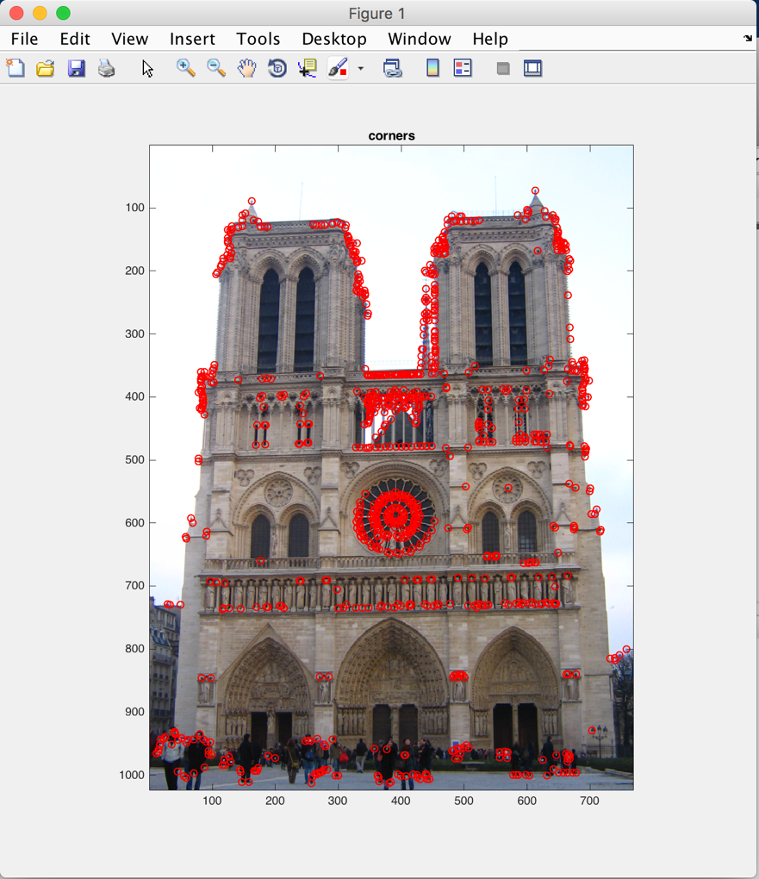

Fig1. Corners in NotreDame picture(sigma=1)

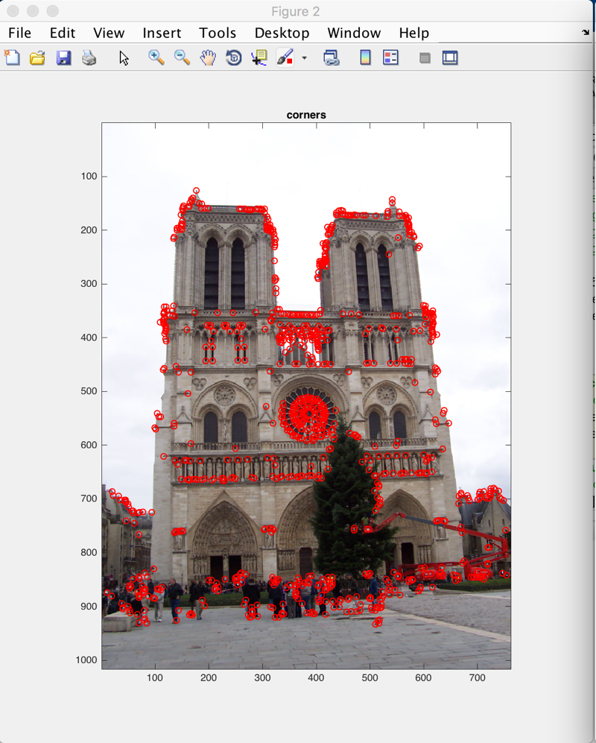

Fig2. Corners in the NotreDame2 picture (sigma=1)

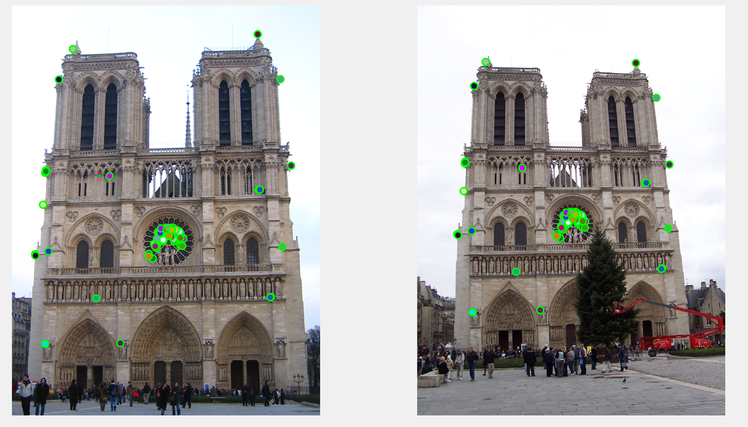

Fig3. Matching in the NotreDame pictures (67 good/0 bad matching)

**(%100 accuracy**), (sigma=1, threshold=0.665)

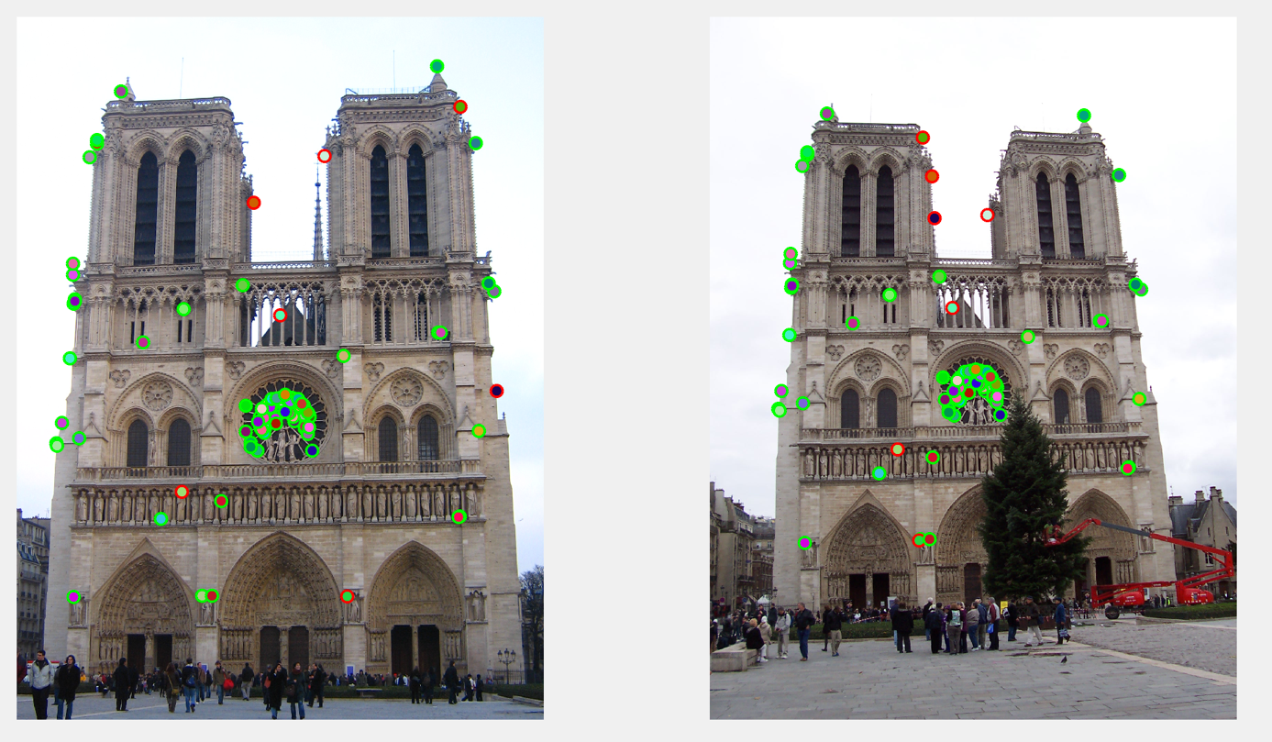

Fig4. Matching in the NotreDame pictures (94 good/7 bad matching)

(% 93.1 accuracy), (sigma=1, threshold=0.72)

## Keble

I found that best sigma value for Keble is 0.3 and best threshold values is 0.62. In that value it has %100 good matches.

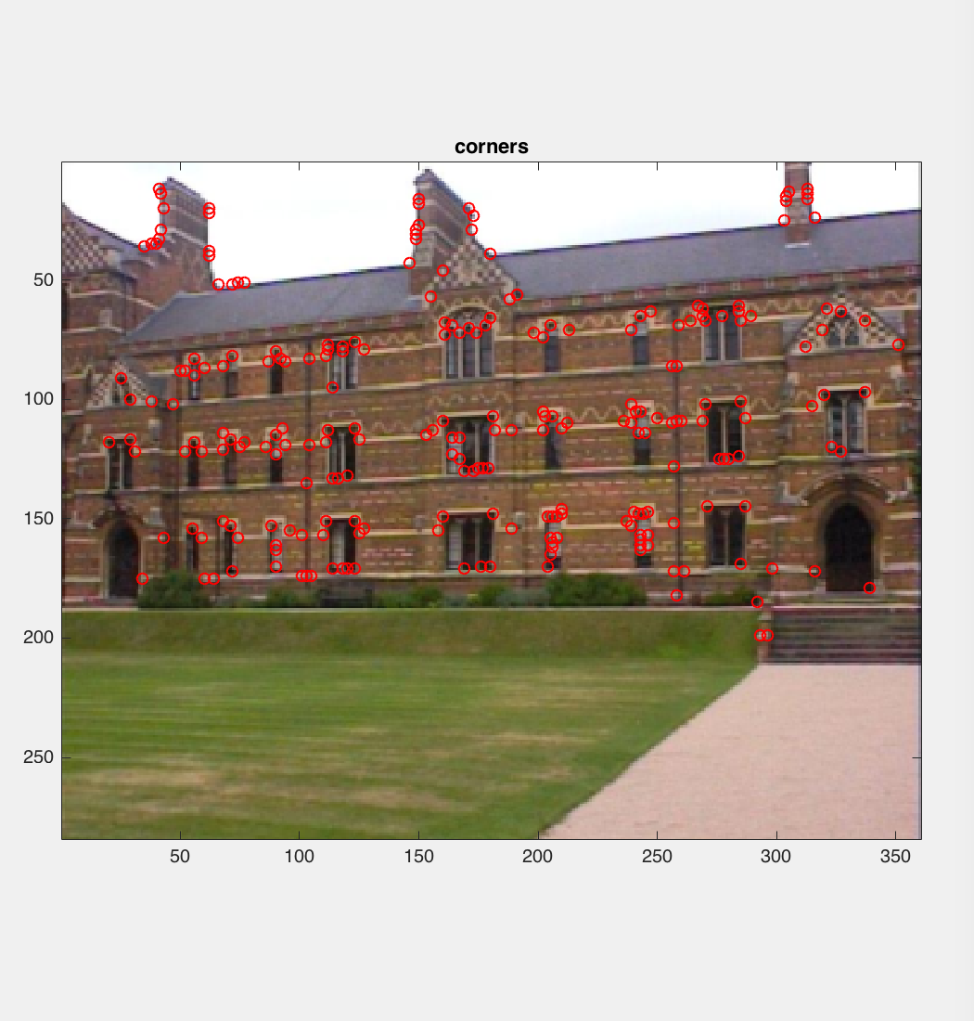

Fig5. Corners in Keble1(sigma=0.3)

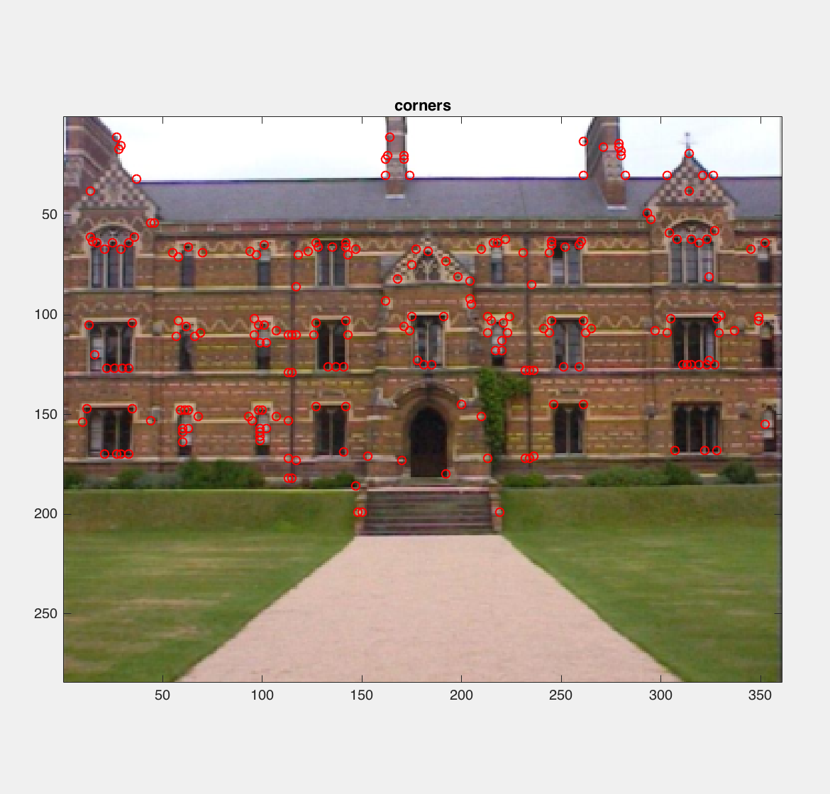

Fig6. Corners in Keble2(sigma=0.3)

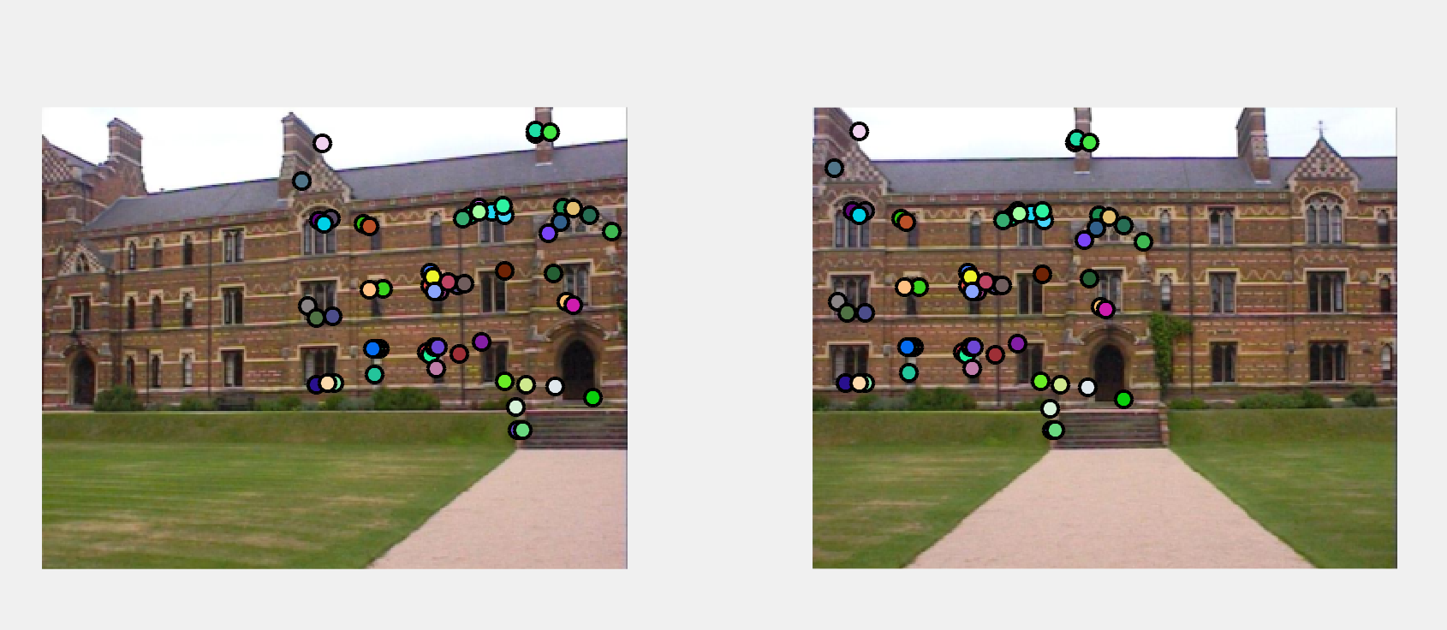

Fig7. Matchin in Keble Images(sigma=0.3, threshold=0.62)(61 Good/0 Bad matches)(%100 accuracy)

## Library:

I took photo of same scene with different positions in the SKL in the university. I test my algorithm at those images.

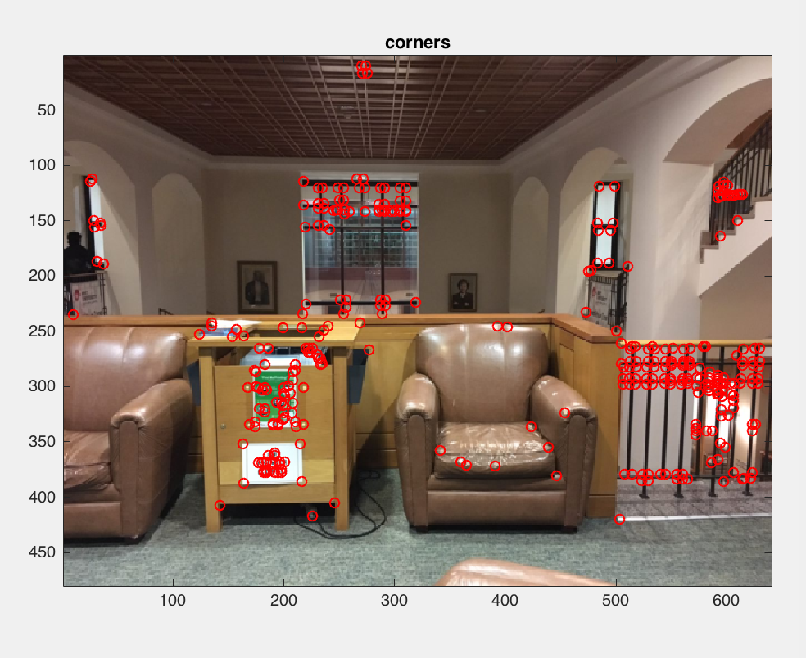

Fig8. Corners in library1(sigma=0.7)

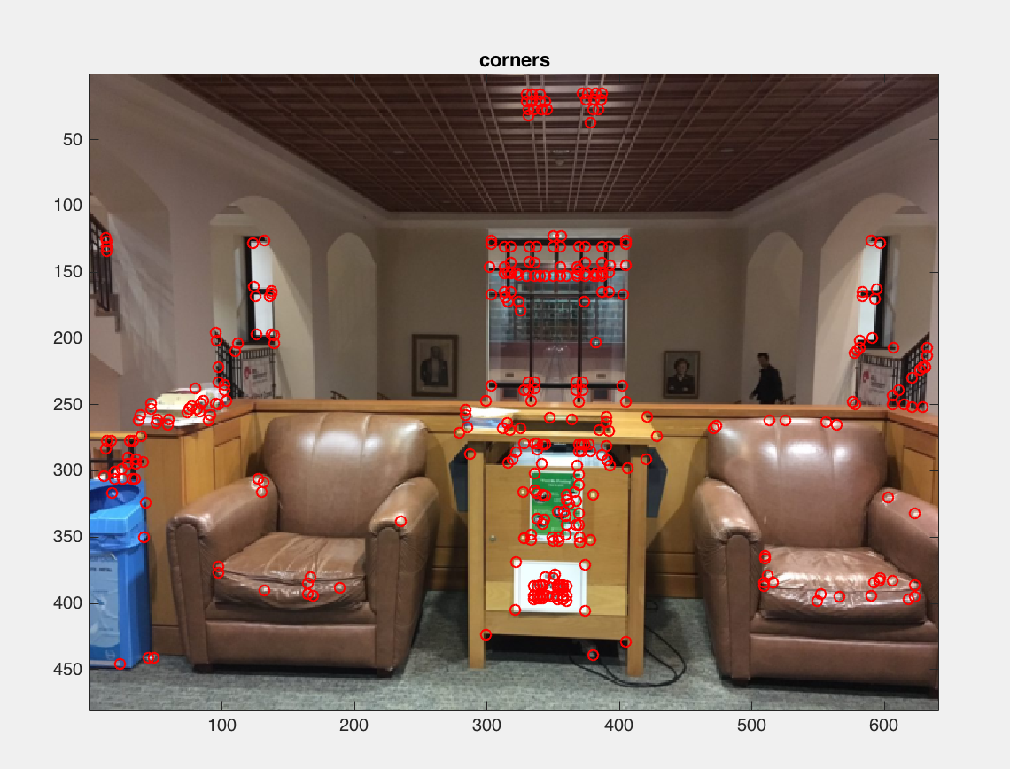

Fig9. Corners in library2(sigma=0.7)

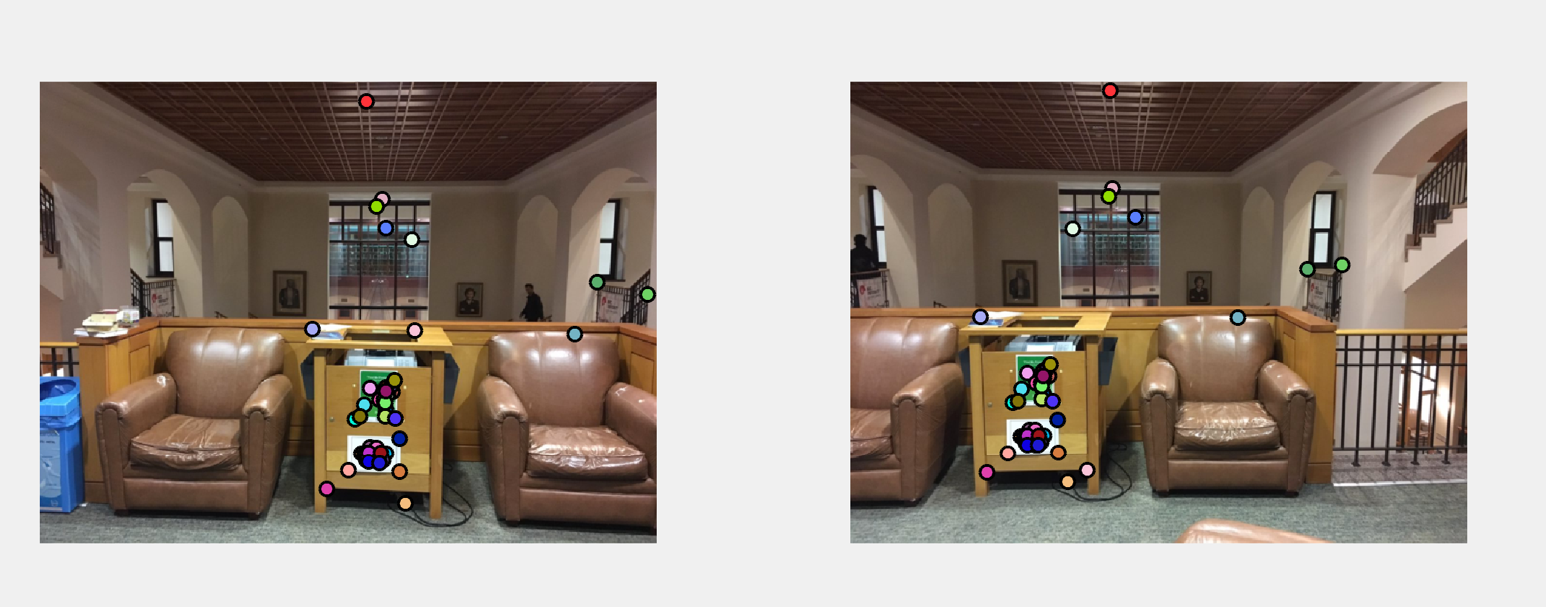

Fig10. Matching in Library pictures (sigma=0.7, threshold=0.7)(~43good matches/~3 bad matches)

Me:

I took my photo and I tried algorithm on my pictures.

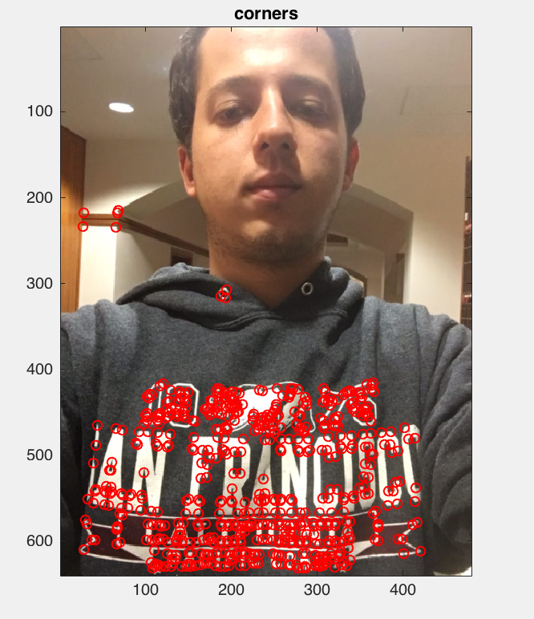

Fig11. Corners in Me1.(sigma=0.5)

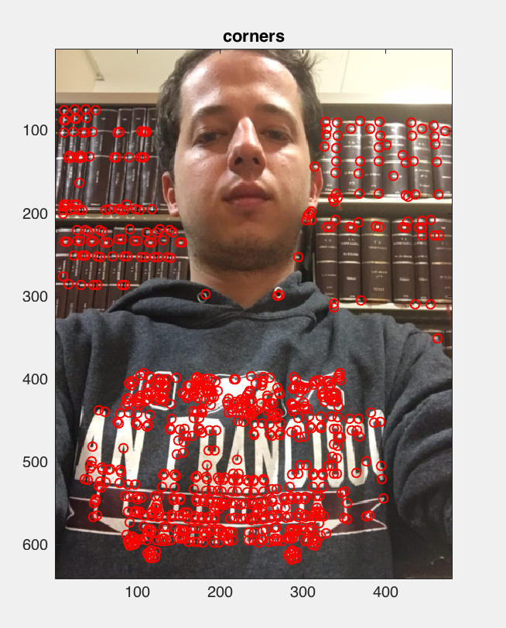

Fig12. Corners in Me2(sigma=0.5)

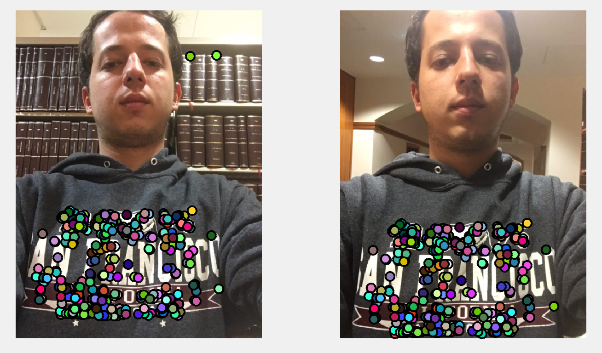

Fig13. Matching in Me pictures. (sigma=0.5,threshold=0.65)

# PCA for Color Gradient

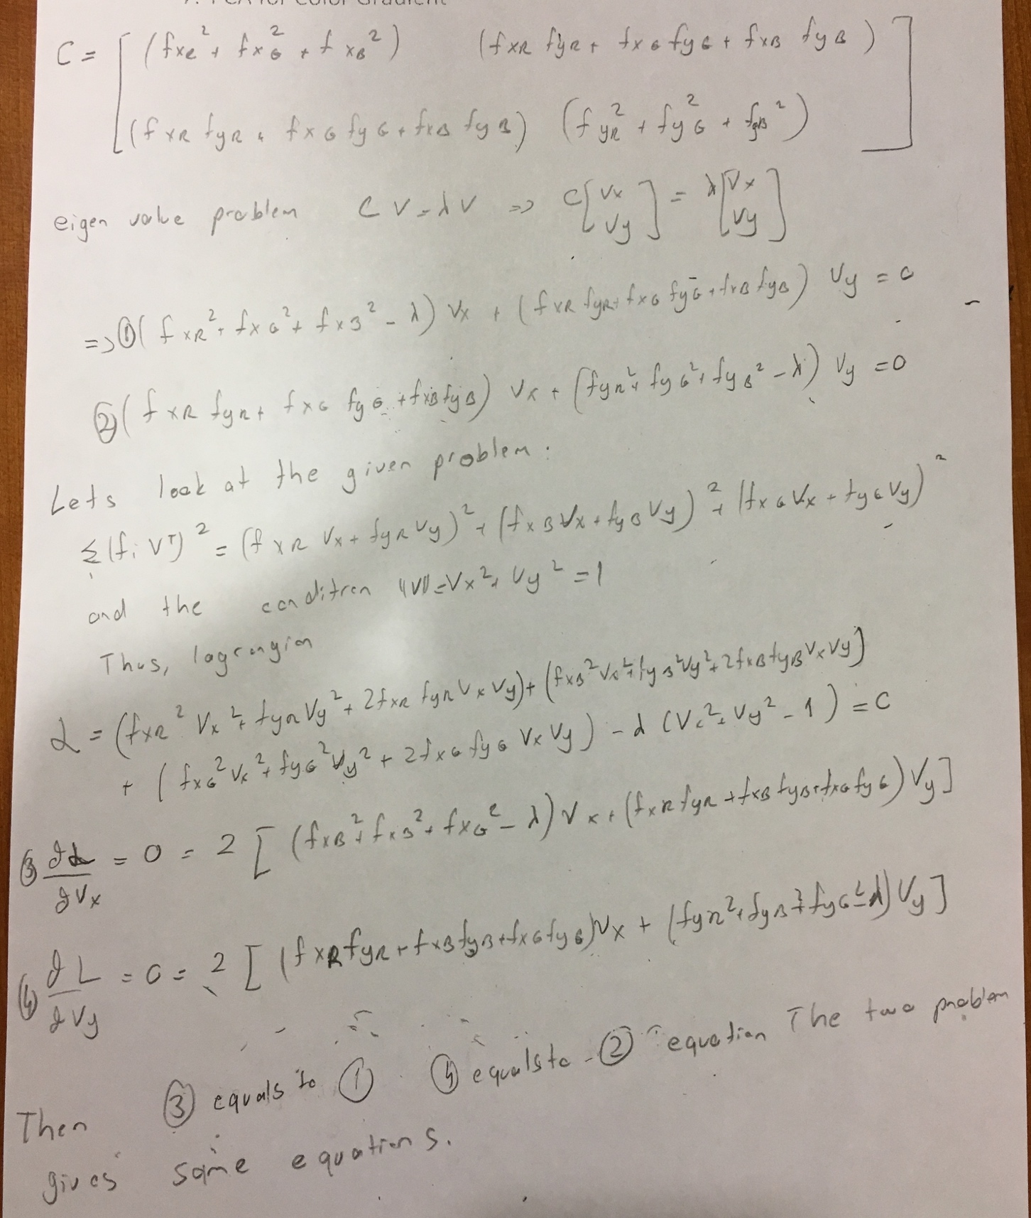

# Conclusion

My algorıthm works very well on given two images and images that I took. However, it didn’t work properly on Shrek image in the dataset. Because my algorithm is not rotational invariant. I started to implement scale and rotational invariant sift but there was no enough time to complete it.

# Bonus Part

## Scale Invariant Feature Detection

I completed the scale invariant part in my project. In the get_interest points, I start from sigma=0.3